Manufacturing Prototype

Team 1253

Nashville, Tennessee, 2025

Table of Contents

Table of Contents 2
Research into existing solutions to the problem with photographs. 3
Sketches of Possible Solution 4
Isometric Assembly Drawing 5
Detailed Drawings 6-13
Photos of Construction of Prototype 13-14
Designs Tested 15-16
Bill Of Materials 17
Work Log 18-19

Research of Current Solutions to the Topic

One current solution is the Convertible Whiteboard Picture Frame that is for home offices or kitchen spaces where it can be used functionally. The main panel of the frame can be changed between a dry-erase whiteboard or a photograph showcase depending on what you want. It was made of lightweight aluminum and the front of the frame opens with a magnetic catch to any printed photos or planners.
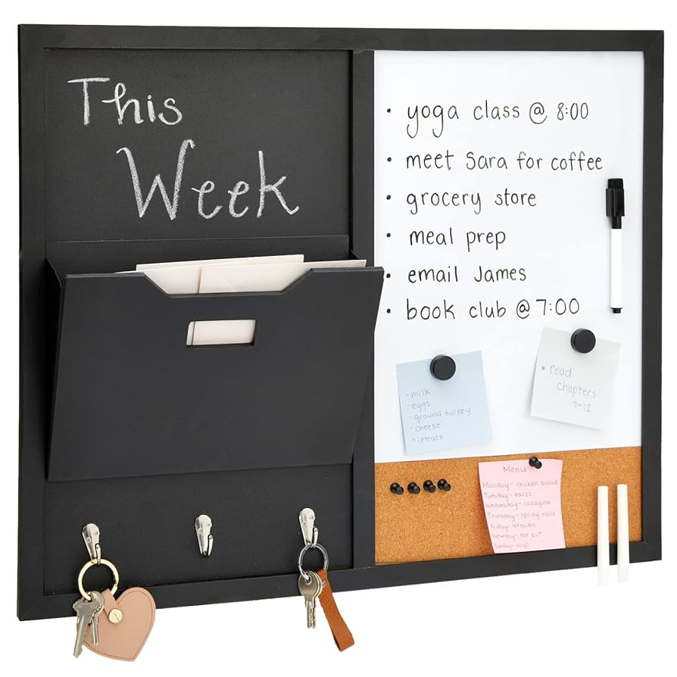
The whiteboard's first layer is made out of tempered glass with a non-ghosting finish that is overlaid by a metallic coating that also supports magnetic items. The most common frames for this are 11x14 inch orientations that are provided with inbuilt dry-erase marker containers or small storage pouches on the frame for more utility. The reverse side includes mounting equipment which is used for putting it inside two or four-point wall anchors.

This is perfect for small spaces which lets the user change between a style and a useful planner without skipping a beat.

Sketches Of Possible Solutions
